
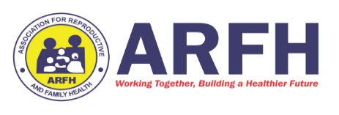

Title of Activity: Outreach
Name of LGA: ETCHE Population of the LGA:
Name of Community: OKEHI
Venue of Activity: SDA SCHOOL
Date of Implementation: 9/6/2026
Month/Quarter: 2
Introduction /Background
On 9TH June 2026, a tuberculosis (TB) awareness and screening outreach was conducted at Seventh day Adventist Nursery & Primary School, Okehi community, Etche LGA of Rivers State, as part of efforts to intensify TB case finding and awareness during the World TB activities. The outreach aimed to educate students and staff on TB while also providing on-site screening services.
A key highlight of the activity was the deployment of the PDX machine to the school, which enabled immediate testing and improved access to diagnostic services for individuals with presumptive TB symptoms. This approach helped bridge the gap between awareness and prompt diagnosis.
The activity commenced with a health education session where participants were enlightened on tuberculosis, including its causes, symptoms, mode of transmission, prevention, and treatment. Emphasis was placed on recognizing symptoms such as persistent cough, weight loss, fever, and night sweats, and the importance of early testing.
Following the sensitization, individuals with symptoms suggestive of TB were identified and screened. The PDX machine deployed on-site was used to carry out diagnostic testing, ensuring quick and efficient results. Participants were also given the opportunity to ask questions, and misconceptions about TB were addressed.

Summary of activities conducted are:
- Planning meeting with TBLS and CTWs. 4/6/26
- Mobilization/Advocacy meeting 5/6/26
- Community Outreach. 9/9/26
- Collection and transportation of sputum samples. 9/9/26
- Collection of Results/Enrollment of cases. 15/6/26
Community TB/HIV Action Plan:
DOLF to continue providing education on TB prevention, symptoms, and treatment options
Sensitization and education on TB
Active case finding

Methodology: The methodology used includes:
• Advocacy visit to the stakeholders of the school
• Health talk
• HIV Counseling
• TB Screening.

Lesson Learnt:
One of the primary lessons from this event was the crucial role of education in combating health issues like TB. Many students displayed a lack of understanding regarding the disease, its transmission, and the implications it has on health and society. This highlighted the need for ongoing educational programs that can demystify TB and encourage preventative health practices. Another significant takeaway was the importance of community involvement. Engaging with students not only instilled knowledge but also fostered a sense of responsibility towards caring for their community. Feedback from participants indicated a heightened awareness and a willingness to participate in future health initiatives.
School-based outreaches are effective platforms for disseminating health information to a wider audience.
Using simple, relatable language enhances understanding, especially among younger participants.
Interactive sessions encourage participation and help in correcting misconceptions.
There is a need for more educational materials to support awareness activities.

Challenges:
Despite the success, several challenges arose during the activities:
- Stigmatization of TB Patients: Some individuals expressed fear of being stigmatized if they were tested for TB. Combating this stigma remains a challenge that requires ongoing community education and support.
- Insufficient Request Forms

Achievement:
- Reached out to 150 school pupils
- TB Awareness creation Increased awareness and knowledge of TB among students and staff.
- Improved understanding of TB symptoms and the need for early testing.
- Active participation and engagement from students during the session.
- Reduction in stigma through open discussions and clarification of myths surrounding TB.
- Successful conduct of TB awareness and sensitization among students and staff.
- Deployment and utilization of the PDX machine for on-site TB screening.
- Increased awareness on TB signs, symptoms, and prevention.
- Identification and testing of presumptive TB cases.

Recommendation
- Supply of Request and Result Forms: Ensure adequate stock to avoid future shortages

- Regular Outreach Programs: Recommended to sustain momentum and address the health needs of the community

Outcome of activities:
S/N | Type of Activity | Number carried out/  Identified | Details of Coverage & Reach | No. Of people reached |  | Total | Remarks
 |  |  |  | M | F | Total
1. | Advocacy and IPC |  |  | 1 | 1 | 2
2. | Awareness prog/Outreach |  |  | 52 | 98 | 150
3 | No of PTB screened with the PDX machine |  |  | 42 | 63 | 105
4 | No of PTB screened symptomatically |  |  | 42 | 66 | 108
5 | No of PTB investigated |  |  | 18 | 11 | 29
6 | No of Positive TB Detected |  |  | 0 | 0 | 0
7 | No +TB Placed on Treatment.

Event Highlights in Pictures:

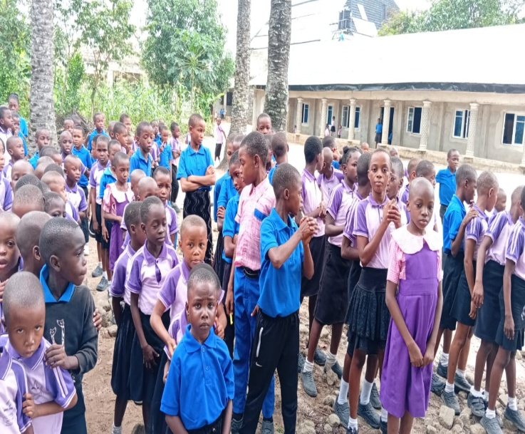 | 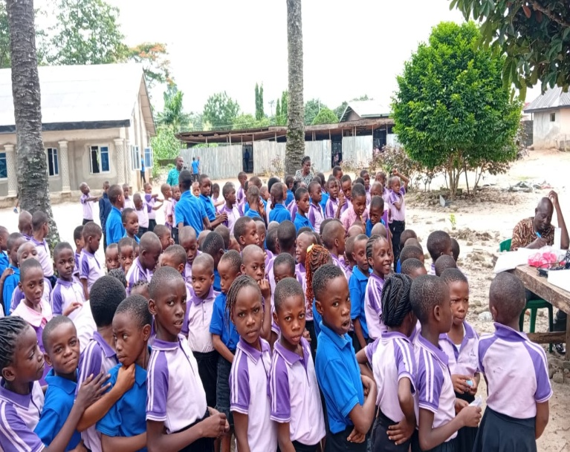
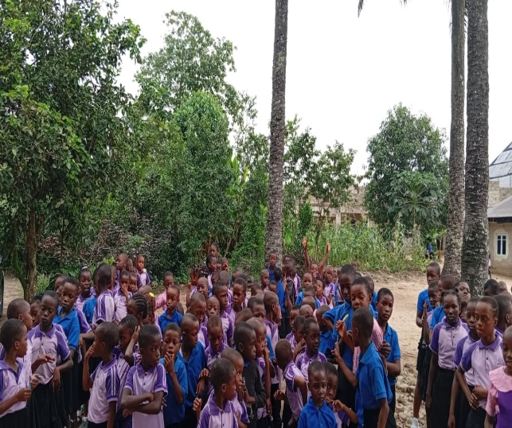 | 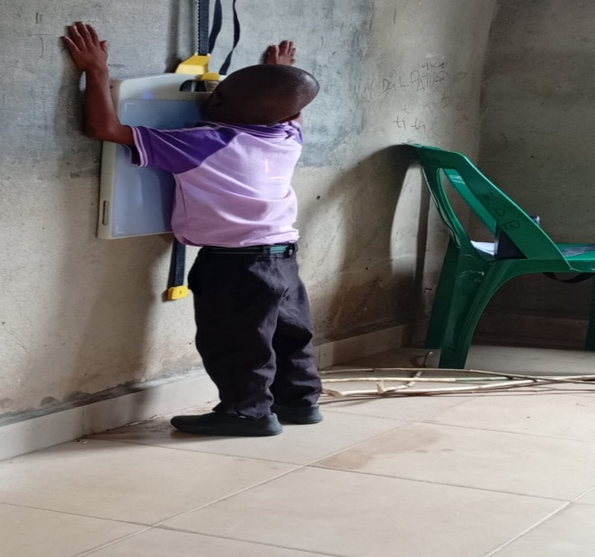

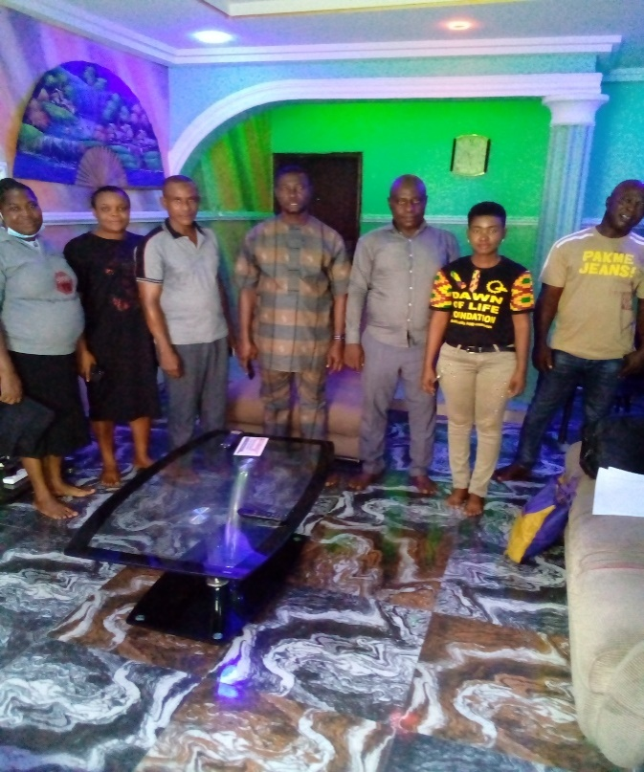
Attestation:
DESCRIPTION | LEAD/PARTNER CBO | TBLS
Name of the Officer Reporting | INNOCENT GOLD | GODPOWER ONYECHE
Designation | PMTCT FP | TBLS
Signature
Date | 09/06/2026 | 09/06/2026

